ORIGINAL ARTICLE
Comparison of IndoBERT and mDeBERTa-v3 for aspect-based sentiment analysis on Gojek application reviews with LLM-assisted labeling and semantic network analysis
Nathanael Silaban¹
Received: … / Accepted: … / Published online: …
© The Author(s) 2025
Abstract User reviews of the Gojek application on the Google Play Store frequently express opinions toward several service aspects within a single text, so that document-level sentiment analysis is insufficient to explain the user experience in detail. This study performs Aspect-Based Sentiment Analysis (ABSA) on Gojek reviews by comparing a monolingual Indonesian transformer (IndoBERT) with a multilingual transformer (mDeBERTa-v3), supported by Large Language Model (LLM)-assisted labeling using Qwen2.5-0.5B-Instruct and Semantic Network Analysis (SNA). Following the CRISP-DM framework, 50,000 raw reviews were reduced to 37,790 cleaned reviews and expanded into 51,098 aspect-level instances over six service aspects and three sentiment classes. An epoch-variation experiment (1–10 epochs) justified the training configuration, and the models were evaluated with per-class reports, confusion analysis, and a train–test generalization analysis. IndoBERT achieved the best performance, with an accuracy of 0.9677 and a macro F1-score of 0.9656, outperforming mDeBERTa-v3 (accuracy 0.8941; macro F1-score 0.8886) despite having 2.24 times fewer parameters. Train–test macro F1 gaps of 0.0268 (IndoBERT) and 0.0110 (mDeBERTa-v3) indicate that both models generalize well. SNA reveals that the word driver dominates opinion formation, co-occurring strongly with terms describing waiting time, difficulty, and order cancellation. The best model was deployed in a Streamlit dashboard that passed thirteen black-box test scenarios, demonstrating that the integrated ABSA–LLM–SNA pipeline supports data-driven service monitoring.
Keywords Aspect-based sentiment analysis · IndoBERT · mDeBERTa-v3 · LLM-assisted labeling · Semantic network analysis · Gojek reviews
¹ Department of Information Systems, Universitas Multimedia Nusantara, Tangerang 15810, Indonesia. Corresponding author: nathanael.silaban@student.umn.ac.id

Introduction
The rapid growth of digital multi-service platforms in Indonesia has made applications such as Gojek a central part of daily activities, ranging from transportation and food delivery to digital payment. As the number of users increases, the volume of reviews on distribution platforms such as the Google Play Store grows substantially. These reviews are a valuable source of unstructured opinion data that, when processed into information, can support decision-making for service improvement; from an information systems perspective, the core challenge is transforming large volumes of unstructured textual feedback into structured, actionable knowledge for the organization [1, 2].
A single Gojek review often expresses opinions toward several service aspects at once. A user may praise the speed of a driver while complaining about the application interface in the same sentence. Document-level sentiment analysis, which assigns a single polarity to an entire review, cannot capture this level of detail. Aspect-Based Sentiment Analysis (ABSA) addresses this limitation by identifying the specific aspects discussed in a review and the sentiment associated with each aspect [3].
Recent advances in pre-trained transformer language models have substantially improved sentiment classification performance [4, 5]. For Indonesian text, IndoBERT a monolingual model pre-trained on large Indonesian corpora has shown strong results on Indonesian classification tasks [6], whereas multilingual models such as mDeBERTa-v3 [7] offer cross-lingual coverage through disentangled attention and ELECTRA-style pre-training. It is therefore relevant to compare a language-specific model against a multilingual model on Indonesian application reviews to determine which is more suitable for ABSA in this domain.
A major obstacle in ABSA research for low-resource languages is the scarcity of labeled data: manual annotation of aspect and sentiment labels is time-consuming and costly. To address this, the present study adopts an LLM-assisted labeling approach using Qwen2.5-0.5B-Instruct [8], following recent work demonstrating that labels generated by large language models can effectively support supervised text classification, provided their quality is validated [9, 10]. The labels are treated as machine-assisted drafts subject to stratified human validation, not as ground truth.
The main contributions of this study can be summarized as follows:
1. Constructing a large aspect-level ABSA dataset of 51,098 instances from 37,790 cleaned Gojek reviews through LLM-assisted labeling with stratified human validation, addressing the scarcity of labeled Indonesian resources;
2. Providing a rigorous head-to-head comparison between a monolingual (IndoBERT) and a multilingual (mDeBERTa-v3) transformer that goes beyond a single headline metric, covering an epoch-variation experiment, per-class evaluation, confusion analysis, and a train–test generalization analysis;
3. Integrating the classification results with Semantic Network Analysis and demonstrating practical applicability through a deployed, black-box-tested Streamlit dashboard.
The subsequent sections of this paper are organized as follows. Section “Related work” surveys ABSA methods, transformer models for Indonesian text, and LLM-assisted annotation. Section “Research methodology” details the data pipeline and model configuration. Section “Experiments” presents the parameter selection experiment, results, and analysis. Section “Concluding remarks” closes the paper.
Related work
Sentiment analysis, often referred to as opinion mining, extracts subjective orientation from text and has developed into one of the most active areas of natural language processing [1]. ABSA refines this task by extracting aspect sentiment pairs, each associating a focal aspect of an entity with its polarity and is widely used to assess consumer feedback on products and services [3]. Recent surveys map the task formulations, methods, applications, and open challenges of ABSA, underscoring its rapid development in the last few years [11, 3]. This study follows the aspect-category classification formulation, in which a predefined set of service aspects is used.
Methodologically, early ABSA studies relied on lexicons and classical machine learning, but transformer-based models have become the dominant approach owing to their contextual representations; hybrid designs such as CNN over BERT-GCN illustrate this trend [12]. More recent context-aware architectures, such as DCASAM, combine BERT with deep bidirectional LSTM and densely connected graph convolutions to capture long-distance dependencies and subtle contextual variation, improving accuracy and F1 on standard ABSA benchmarks [13]. BERT-based frameworks have likewise proven effective on noisy, informal social-media text [14], which shares many characteristics with application reviews.
For Indonesian, IndoBERT has shown strong results across sentiment and aspect-based classification tasks, including hotel reviews and customer feedback [6, 15]. Multilingual encoders such as mDeBERTa-v3 are trained on many languages simultaneously [7], and benchmark studies on Indonesian sentiment suggest that monolingual models often outperform multilingual ones on language-specific tasks, although multilingual models remain competitive for code-mixed content [16]. A direct comparison of the two families on a large Indonesian ABSA dataset, evaluated beyond a single headline metric, is still rare a gap this study addresses.
Regarding annotation, using large language models to generate training labels has emerged as a practical strategy for low-resource settings [9, 10]. LLM-based and zero-shot labeling has been applied to service-domain reviews, including tourism experiences [17] and hospitality analytics [18], with a consistent finding: machine-generated labels reduce annotation cost but require human validation as an essential safeguard. This study operationalizes that principle through a small, locally runnable instruction-tuned model combined with stratified manual checking.
Research methodology
This study follows the Cross-Industry Standard Process for Data Mining (CRISP-DM), covering business understanding, data collection, data preparation, LLM-assisted labeling, modeling, evaluation, and deployment. The overall research framework is illustrated in Fig. 1.
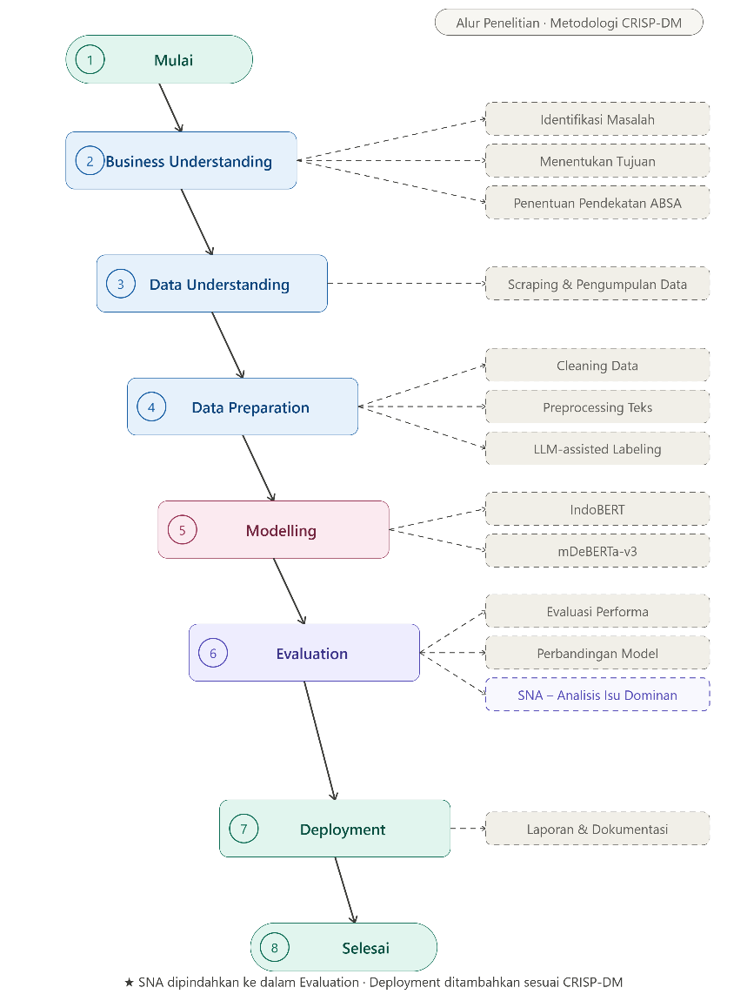
Figure 1. Research flow based on CRISP-DM
Data collection
Review data were collected from the Google Play Store using the google-play-scraper library with the application identifier com.gojek.app, yielding 50,000 raw Indonesian-language reviews with their metadata (rating, timestamp, and review text).
Data preparation and data-loss analysis
Cleaning removed duplicate identifiers, empty texts, and reviews shorter than two tokens after normalization, leaving 37,790 usable reviews. A per-step data-loss analysis showed that the entire reduction of 12,210 reviews (24.42%) was caused by a single dominant factor texts that were too short after normalization rather than by duplication or missing values. Inspection of the removed records revealed that most carried five-star ratings with generic one-word praise (e.g., “bagus”, “top”, “oke”) or emoji-only content, which cannot be meaningfully paired with a service aspect. Preprocessing was deliberately light (case folding, word normalization, whitespace cleanup) because transformer models require sentence context to interpret meaning.
LLM-assisted labeling and human validation
Aspect and sentiment labels were assigned with Qwen2.5-0.5B-Instruct running locally, chosen for its instruction-following capability at a size small enough for offline, low-cost batch annotation [8]. Each review was mapped to one or more of six predefined aspects Application, Service, Driver, Price and Tariff, GoPay and Payment, and Promotion and Advertisement with positive, negative, or neutral polarity. To control label quality, a stratified manual validation of 300 samples covering all aspect–sentiment combinations was performed: aspect identification reached 90% agreement, sentiment polarity 61.33%, and the full aspect–sentiment pair 54.67%. These results confirm that the LLM recognizes what a review is about more reliably than how the user feels, so its output is used strictly as assisted drafting subject to verification, consistent with prior findings on LLM annotation [9, 10].
Aspect-level dataset construction and splitting
Because one review may discuss several aspects, the labeled data were expanded into aspect-level instances, producing 51,098 rows of (review text, aspect, sentiment). The dataset was split into 80% training and 20% testing 40,886 and 10,212 instances, respectively using a grouped split by review identifier so that no review appears in both partitions, preventing leakage. The 80:20 ratio follows established guidance on data splitting [19], and stratification preserves the label distribution across partitions.
Model fine-tuning configuration
IndoBERT (124,443,651 parameters) and mDeBERTa-v3 (278,811,651 parameters; 2.24 times larger) were fine-tuned on identical data and evaluation protocols for sequence classification. The learning rate and epoch range were guided by prior work on fine-tuning IndoBERT for Indonesian application-review sentiment [20, 21]. Training minimized a class-weighted cross-entropy loss, with inverse-frequency weights (negative 1.0340, neutral 1.2516, positive 0.8104) to counter class imbalance. Table 1 summarizes the configuration; the number of epochs for IndoBERT was determined empirically through the parameter selection experiment reported below.
Table 1 Fine-tuning parameter configuration
Parameter | Value
Optimizer | AdamW
Learning rate | 2e-5
Batch size | 16
Maximum sequence length | 128
Loss function | Class-weighted cross-entropy
Epochs | 4 (IndoBERT), 3 (mDeBERTa-v3)
Framework | PyTorch + Hugging Face Transformers
Evaluation indicators
Model performance is measured using accuracy, precision, recall, and F1-score. Accuracy is the proportion of correctly classified instances, computed as (TP + TN) / (TP + TN + FP + FN), where TP, TN, FP, and FN denote true positives, true negatives, false positives, and false negatives. Precision is defined as P = TP / (TP + FP), recall as R = TP / (TP + FN), and the F1-score as their harmonic mean, F1 = 2PR / (P + R). Macro-averaged scores weight the three sentiment classes equally, so that performance on the minority neutral class is not masked by the majority classes, whereas weighted averages account for class support. Beyond aggregate metrics, evaluation includes per-class reports, confusion matrices, a comparison of training versus test macro F1 to assess overfitting, and computational complexity in terms of parameter count.
After model selection, Semantic Network Analysis based on keyword co-occurrence was applied to reviews with positive and negative sentiment to map the words and issues that shape user opinion an analytical approach widely used to chart concept associations in consumer research [22].
Experiments
Dataset description
Table 2 presents the composition of the aspect-level dataset. Service, Driver, and Application together account for more than 80% of the data, indicating that user feedback concentrates on the core experience of ordering, drivers, and application usage.
Table 2 Aspect composition of the dataset
Aspect | Count | Percentage
Service | 16,946 | 33%
Driver | 13,896 | 27%
Application | 10,931 | 21%
Price and Tariff | 3,635 | 7%
GoPay and Payment | 3,334 | 7%
Promotion and Advertisement | 2,356 | 5%
Total | 51,098 | 100%
Table 3 shows the sentiment distribution after the grouped 80:20 split. The proportions are preserved across partitions (41% positive, 32% negative, 27% neutral), confirming that stratification succeeded.
Table 3 Sentiment distribution in the training and test sets
Class | Train | % | Test | %
Positive | 16,817 | 41% | 4,170 | 41%
Negative | 13,180 | 32% | 3,292 | 32%
Neutral | 10,889 | 27% | 2,750 | 27%
Total | 40,886 | 100% | 10,212 | 100%
Parameter selection experiment
To justify the training duration, an epoch-variation experiment from 1 to 10 epochs was conducted for IndoBERT on a validation split derived from the training data with a grouped split, keeping the test set untouched. Table 4 reports the results.
Table 4 Epoch-variation results for IndoBERT on the validation set
Epoch | Training loss | Validation loss | Macro F1
1 | 0.6461 | 0.3141 | 0.9083
2 | 0.3170 | 0.2617 | 0.9447
3 | 0.1922 | 0.2885 | 0.9486
4 | 0.1302 | 0.2607 | 0.9546
5 | 0.0928 | 0.2760 | 0.9557
6 | 0.0552 | 0.3701 | 0.9491
7 | 0.0366 | 0.2910 | 0.9560
8 | 0.0193 | 0.3326 | 0.9568
9 | 0.0100 | 0.3712 | 0.9564
10 | 0.0082 | 0.3584 | 0.9580
Macro F1 improves sharply up to epoch 4 (0.9546) and only marginally afterward (0.9580 at epoch 10, a gain of 0.0034 over six additional epochs), while validation loss reaches its minimum at epoch 4 (0.2607) and then fluctuates upward as training loss keeps falling the classic signature of emerging overfitting. Epoch 4 was therefore selected for IndoBERT as the best trade-off between performance and generalization; mDeBERTa-v3 used 3 epochs as a baseline configuration given its larger parameter count.
Experimental results and analysis
Table 5 compares both models on the held-out test set of 10,212 instances. IndoBERT outperforms mDeBERTa-v3 on every metric, with margins of 0.0736 in accuracy, 0.0771 in macro precision, 0.0753 in macro recall, 0.0770 in macro F1, and 0.0723 in weighted F1. Notably, the smaller model wins: mDeBERTa-v3 carries 2.24 times more parameters yet trails by roughly 7.7 macro F1 points on this Indonesian-dominant corpus, indicating that language fit matters more than model size and that the selected model is also cheaper to serve.
Table 5 Test-set performance comparison
Metric | IndoBERT | mDeBERTa-v3 | Difference
Accuracy | 0.9677 | 0.8941 | 0.0736
Macro precision | 0.9645 | 0.8874 | 0.0771
Macro recall | 0.9669 | 0.8916 | 0.0753
Macro F1-score | 0.9656 | 0.8886 | 0.0770
Weighted F1-score | 0.9678 | 0.8955 | 0.0723
Parameters | 124,443,651 | 278,811,651 | 2.24×
Tables 6 and 7 report the per-class results. Both models are evaluated on the same test distribution (3,292 negative, 2,750 neutral, 4,170 positive). For both, the neutral class is the hardest F1 of 0.9430 for IndoBERT and 0.8269 for mDeBERTa-v3 reflecting the semantic overlap between neutral reviews and the polar classes.
Table 6 Classification report of IndoBERT
Class | Precision | Recall | F1-score | Support
Negative | 0.9792 | 0.9748 | 0.9770 | 3,292
Neutral | 0.9297 | 0.9567 | 0.9430 | 2,750
Positive | 0.9847 | 0.9693 | 0.9769 | 4,170
Macro avg | 0.9645 | 0.9669 | 0.9656 | 10,212
Weighted avg | 0.9681 | 0.9677 | 0.9678 | 10,212
Table 7 Classification report of mDeBERTa-v3
Class | Precision | Recall | F1-score | Support
Negative | 0.9190 | 0.8964 | 0.9076 | 3,292
Neutral | 0.7875 | 0.8705 | 0.8269 | 2,750
Positive | 0.9558 | 0.9079 | 0.9313 | 4,170
Macro avg | 0.8874 | 0.8916 | 0.8886 | 10,212
Weighted avg | 0.8986 | 0.8941 | 0.8955 | 10,212
Generalization analysis
To assess overfitting explicitly, macro F1 on the training set was compared with the test set for both models (Table 8). IndoBERT obtained 0.9924 on training versus 0.9656 on testing (gap 0.0268), while mDeBERTa-v3 obtained 0.8996 versus 0.8886 (gap 0.0110). Both gaps lie well below the 0.05 threshold commonly used as an early indication of overfitting, so both models generalize well to unseen reviews despite their different absolute performance levels; the smaller gap of mDeBERTa-v3 indicates slightly higher train–test stability, though at a much lower performance ceiling.
Table 8 Train–test macro F1 and generalization gap
Model | Train macro F1 | Test macro F1 | Gap
IndoBERT | 0.9924 | 0.9656 | 0.0268
mDeBERTa-v3 | 0.8996 | 0.8886 | 0.0110
Error analysis
The confusion matrix of IndoBERT (Fig. 2) is dominated by the diagonal, with 3,209 negative, 2,631 neutral, and 4,042 positive instances classified correctly. The largest confusion is positive predicted as neutral (124 instances), followed by negative-as-neutral (75) and neutral-as-negative (64) short, implicit praise and mild complaints are the hardest to separate from neutrality. mDeBERTa-v3 shows the same pattern at larger magnitude (correct diagonal 2,951 / 2,394 / 3,786), with neutral-class precision of only 0.7875. These patterns explain the aggregate scores: errors concentrate around the neutral boundary rather than between the polar classes, which is the least harmful failure mode for service-monitoring applications.
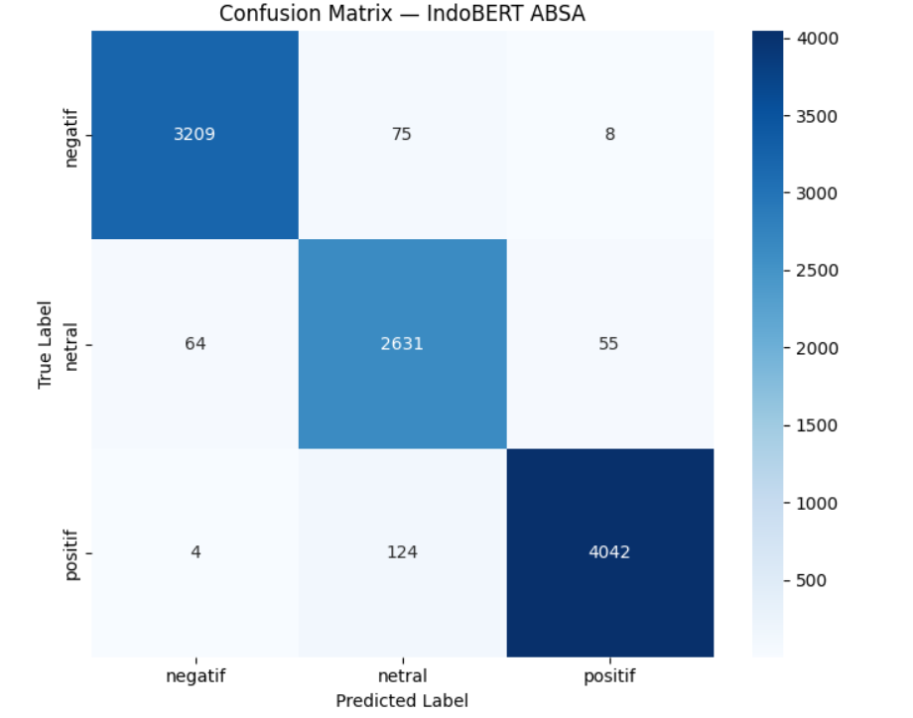
Figure 2. Confusion matrix of the IndoBERT model
Semantic network analysis
SNA was applied to positive and negative reviews, producing a keyword co-occurrence network of 35 nodes and 461 edges. Table 9 lists the strongest pairs and Fig. 3 visualizes the network. The word driver dominates the high-weight pairs and holds the highest degree centrality, co-occurring with lama (long), nunggu (waiting), susah (difficult), and cancel pinpointing waiting time, difficulty obtaining service, and order cancellation as the operational issues shaping negative opinion, while baik (good), bagus (great), and cepat (fast) anchor the positive vocabulary. ABSA identifies which aspect carries which sentiment; SNA explains why, making the two analyses complementary.
Table 9 Top keyword co-occurrence pairs
No. | Word 1 | Word 2 | Weight
1 | driver | lama | 3,119
2 | driver | tapi | 2,707
3 | driver | mau | 2,459
4 | driver | susah | 2,328
5 | driver | padahal | 1,979
6 | driver | nunggu | 1,886
7 | driver | gofood | 1,858
8 | cancel | driver | 1,749
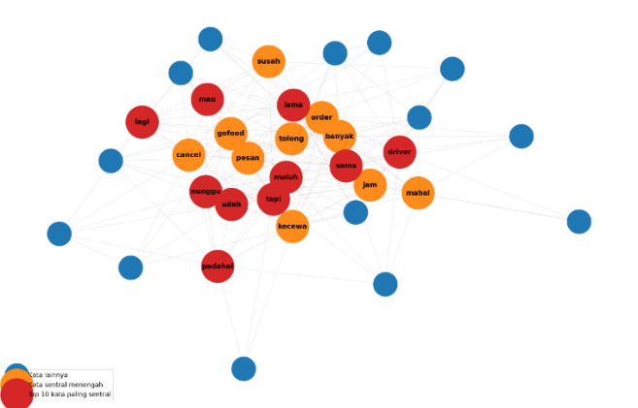
Figure 3. Keyword co-occurrence network for positive and negative reviews
Deployment testing
The best model, IndoBERT, was deployed in an interactive Streamlit dashboard that retrieves reviews by application identifier, runs aspect-based sentiment prediction, summarizes sentiment per aspect, generates automatic conclusions, presents the SNA results, and exports outputs to CSV. Black-box testing of thirteen functional scenarios covering data retrieval, inference, per-aspect summaries, ABSA–SNA integration, and export confirmed that all features operated as expected. The dashboard remains a demonstration rather than a system integrated with Gojek operations.
Discussion
Three findings deserve emphasis. First, the monolingual model decisively outperformed the multilingual one on Indonesian-dominant reviews, consistent with prior evidence from Indonesian benchmarks [16] and IndoBERT applications [6, 15], and extending it with an explicit generalization analysis and complexity comparison. Second, LLM-assisted labeling proved viable but not autonomous: the 90% aspect versus 61.33% sentiment validation accuracy quantifies exactly where a small LLM annotator needs human oversight, sharpening the general guidance in the annotation literature [9, 10]. Third, coupling ABSA with SNA converts classification outputs into operational diagnostics the driver-centered network translates directly into actionable priorities (waiting time, cancellations) in the way service-domain studies advocate [17, 18]. Compared with architecture-centric work such as DCASAM [13], this study contributes an application-and-pipeline perspective: dataset construction, model selection, validation, and deployment for a low-resource industrial domain.
Concluding remarks
This paper presented an end-to-end aspect-based sentiment analysis of Gojek application reviews that combines LLM-assisted labeling, a monolingual–multilingual transformer comparison, semantic network analysis, and a tested deployment. From 50,000 raw reviews, an aspect-level dataset of 51,098 instances across six service aspects was constructed with Qwen2.5-0.5B-Instruct as an annotation aid and stratified human validation. IndoBERT, selected through an explicit epoch-variation experiment, achieved an accuracy of 0.9677 and a macro F1-score of 0.9656 on 10,212 held-out instances outperforming mDeBERTa-v3 by 0.0770 macro F1 while using 2.24 times fewer parameters and both models showed train–test gaps below 0.05, indicating sound generalization.
The analysis shows that the neutral class is the principal source of error for both models, and that user opinion is organized around the driver experience, with waiting time and order cancellation as dominant negative themes. The deployed dashboard, which passed all thirteen black-box test scenarios, demonstrates that the pipeline can support practical service monitoring.
Future work will extend validation coverage of the LLM-generated labels, explore larger or instruction-tuned Indonesian models as annotators and classifiers, incorporate aspect-term extraction alongside aspect-category classification, and integrate the dashboard with live operational data streams.
Abbreviations
Abbreviation | Definition
ABSA | Aspect-Based Sentiment Analysis
CRISP-DM | Cross-Industry Standard Process for Data Mining
LLM | Large Language Model
SNA | Semantic Network Analysis
NLP | Natural Language Processing
F1 | Harmonic mean of precision and recall
Acknowledgements
The authors thank Universitas Multimedia Nusantara for supporting this research.
References
1. Wankhade M, Rao ACS, Kulkarni C (2022) A survey on sentiment analysis methods, applications, and challenges. Artif Intell Rev 55(7):5731–5780. https://doi.org/10.1007/s10462-022-10144-1
2. Min B, Ross H, Sulem E, Veyseh APB, Nguyen TH, Sainz O, Agirre E, Heintz I, Roth D (2023) Recent advances in natural language processing via large pre-trained language models: a survey. ACM Comput Surv 56(2):1–40. https://doi.org/10.1145/3605943
3. Zhang W, Li X, Deng Y, Bing L, Lam W (2023) A survey on aspect-based sentiment analysis: tasks, methods, and challenges. IEEE Trans Knowl Data Eng 35(11):11019–11038. https://doi.org/10.1109/TKDE.2022.3230975
4. Wang H, Li J, Wu H, Hovy E, Sun Y (2023) Pre-trained language models and their applications. Engineering 25:51–65. https://doi.org/10.1016/j.eng.2022.04.024
5. Islam S, Elmekki H, Elsebai A, Bentahar J, Drawel N, Rjoub G, Pedrycz W (2024) A comprehensive survey on applications of transformers for deep learning tasks. Expert Syst Appl 241:122666. https://doi.org/10.1016/j.eswa.2023.122666
6. Singgalen YA (2025) Performance analysis of IndoBERT for sentiment classification in Indonesian hotel review data. J Inf Syst Res 6(2):976–986. https://doi.org/10.47065/josh.v6i2.6505
7. He P, Gao J, Chen W (2023) DeBERTaV3: improving DeBERTa using ELECTRA-style pre-training with gradient-disentangled embedding sharing. In: 11th International Conference on Learning Representations (ICLR 2023), Kigali, Rwanda
8. Qwen Team (2024) Qwen2.5: a party of foundation models! Alibaba Cloud Community. https://www.alibabacloud.com/blog/qwen2-5-a-party-of-foundation-models_601782
9. Pangakis N, Wolken S (2024) Knowledge distillation in automated annotation: supervised text classification with LLM-generated training labels. In: Proceedings of the 6th Workshop on Natural Language Processing and Computational Social Science (NLP+CSS 2024), Mexico City, pp 113–131
10. Tan Z, Li D, Wang S, Beigi A, Jiang B, Bhattacharjee A, Karami M, Li J, Cheng L, Liu H (2024) Large language models for data annotation and synthesis: a survey. In: Proceedings of the 2024 Conference on Empirical Methods in Natural Language Processing (EMNLP 2024), Miami, pp 930–957. https://doi.org/10.18653/v1/2024.emnlp-main.54
11. Nath D, Dwivedi SK (2024) Aspect-based sentiment analysis: approaches, applications, challenges and trends. Knowl Inf Syst 66(12):7261–7303. https://doi.org/10.1007/s10115-024-02200-9
12. Phan HT, Nguyen NT, Hwang D (2022) Aspect-level sentiment analysis using CNN over BERT-GCN. IEEE Access 10:110402–110409. https://doi.org/10.1109/ACCESS.2022.3214233
13. Jiang X, Ren B, Wu Q, Wang W, Li H (2024) DCASAM: advancing aspect-based sentiment analysis through a deep context-aware sentiment analysis model. Complex Intell Syst 10:7907–7926. https://doi.org/10.1007/s40747-024-01570-5
14. Bello A, Ng S-C, Leung M-F (2023) A BERT framework to sentiment analysis of tweets. Sensors 23(1):506. https://doi.org/10.3390/s23010506
15. Yulianti E, Nissa NK (2024) ABSA of Indonesian customer reviews using IndoBERT: single-sentence and sentence-pair classification approaches. Bull Electr Eng Inform 13(5):3579–3589. https://doi.org/10.11591/eei.v13i5.8032
16. Winata GI, Aji AF, Cahyawijaya S, Mahendra R, Koto F, Romadhony A, Kurniawan K, Moeljadi D, Prasojo RE, Fung P, Baldwin T, Lau JH, Sennrich R, Ruder S (2023) NusaX: multilingual parallel sentiment dataset for 10 Indonesian local languages. In: Proceedings of the 17th Conference of the European Chapter of the Association for Computational Linguistics (EACL 2023), pp 815–834. https://doi.org/10.18653/v1/2023.eacl-main.57
17. Nawawi I, Ilmawan KF, Maarif MR, Syafrudin M (2024) Exploring tourist experience through online reviews using aspect-based sentiment analysis with zero-shot learning for hospitality service enhancement. Information 15(8):499. https://doi.org/10.3390/info15080499
18. Kwon W (2026) Aspect-based sentiment analysis through zero-shot text classification and impact-asymmetry analysis. Int J Hosp Manag 133:104397. https://doi.org/10.1016/j.ijhm.2025.104397
19. Joseph VR (2022) Optimal ratio for data splitting. Stat Anal Data Min 15(4):531–538. https://doi.org/10.1002/sam.11583
20. Zaidan MN, Sibaroni Y, Prasetiyowati SS (2024) Learning rate and epoch optimization in the fine-tuning process for IndoBERT performance on sentiment analysis of MyTelkomsel app reviews. Jurnal Teknik Informatika (JUTIF) 5(5):1443–1450. https://doi.org/10.52436/1.jutif.2024.5.5.2396
21. Adhim NF, Cahyono N (2025) Optimization of IndoBERT for sentiment analysis of FOMO on social media through fine-tuning and hybrid labeling. Journal of Applied Informatics and Computing 9(6):3786–3797
22. Schöps JD, Jaufenthaler P (2024) Semantic network analysis in consumer and marketing research: application areas in phygital contexts. Qual Mark Res 27(3):495–514. https://doi.org/10.1108/QMR-06-2023-0084

